**International Week**

**Lucian Blaga University of Sibiu**

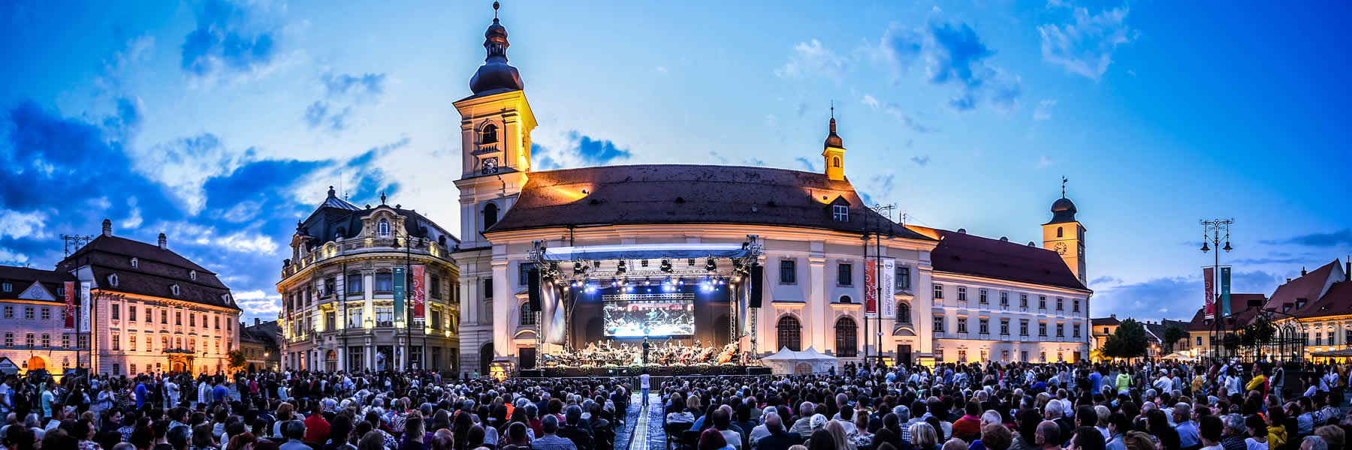

**INVITATION**

**International Week at**

**Lucian Blaga University of Sibiu**

**8 – 13 May 2017**

***”Innovation and Creativity in International Higher Education”***

*4th edition*



**International Week**

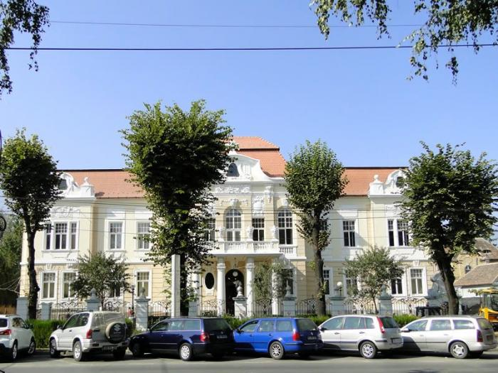**Lucian Blaga University of Sibiu**

Dear colleagues,

It is our pleasure to invite you to attend the 4th edition of the **International Week ofLucian Blaga University of Sibiu**. The aim of this event is to create the opportunity for intercultural exchange between students, practitioners and teachers from all around the world and to foster cooperation between thepartner universities.

This years’ International Week central topic is **”Innovation and Creativity in International Higher Education”**and therefore all the lectures and workshops will be developed around this idea.

**Activities:**

* Lectures held by guest academics for the local students from LBUS Faculties
* Workshops on the internationalization of higher education and the role of innovation and creativity in developing this area Workshop for developing international partnerships and collaboration
* International dinner
* Visits of Romanian heritage (cities, museums, citadels, etc.)
* Traditional music and dancing shows
* Official banquette

**International Week**

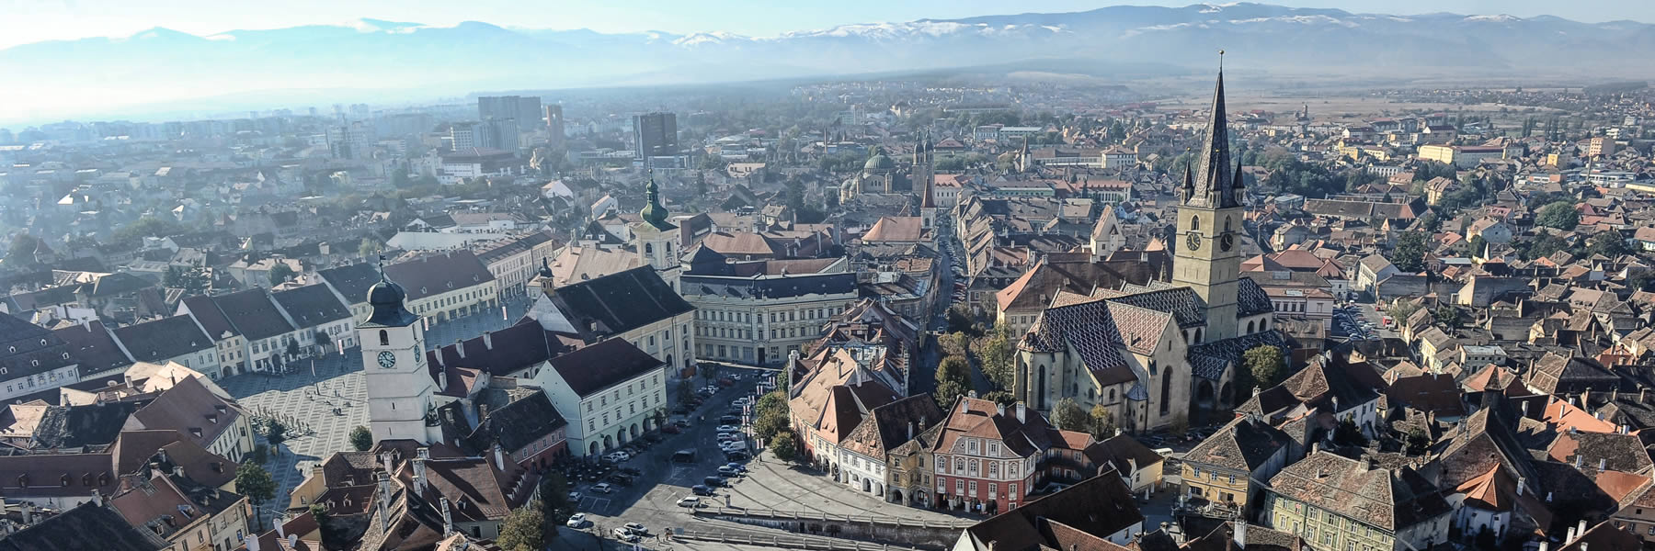**Lucian Blaga University of Sibiu**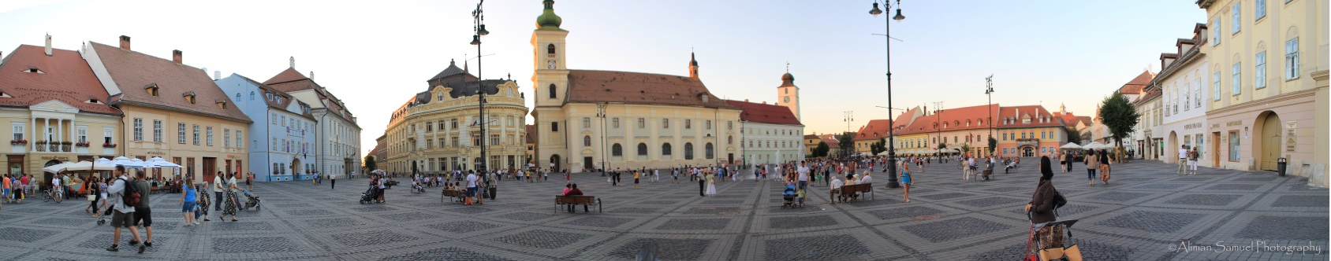

**What is the International Week about?**

During this week, the guests will meet the students and teaching staff from Lucian Blaga University of Sibiu and share with them knowledge and expertise in the different scientific and practical fields.This event will gather all the nine faculties of LBUS together with all the partner universities from Europe and Asia through the central topic of”Innovation and Creativity in International Higher Education”.

Complementary to the academic activities, the week’s program will include social and cultural endeavors which shall enlarge the guests’ experience. The city of Sibiu and its surroundings offer a great variety of natural and architectural displays which favor unique leisure-time activities.

**What should your contribution consist in?**

* Academic guest should prepare a two-hour lecture for an audience which consists of Bachelor, Master Students and professors from the same field of expertise. The lectures will be held in English and therefore a minimum English level of B1 is kindly required.
* The non-academic staff who will join the event will attend the workshops and participate in meetings with administrative personnel from the same field



**ternational Week**

**Lucian Blaga University of Sibiu**

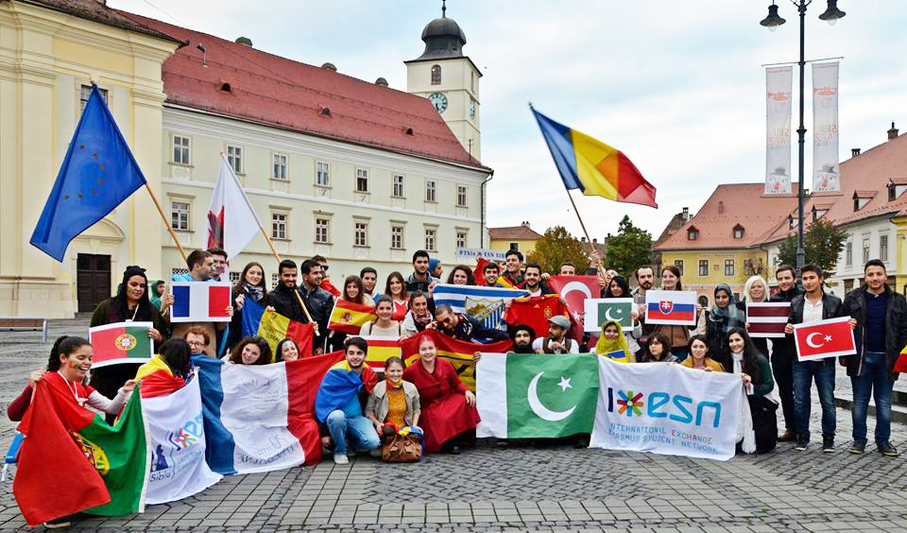

**About Internationalization at Lucian Blaga University of Sibiu**

Having acknowledged that globalization has transformed the world into a “global village”,LBUS has increased its efforts to adjust its educational offer to the new, international demand.

LBUS is part of the Erasmus+ program and over the time the university has developed more than 300 partnerships with universities from Europe and Asia. Every year there are about 150 international students coming to LBUS and about 200 going to partner universities, forastudy or placement mobility.

Knowledge is global and research must transcend the national boundaries. International projects are being carried out by setting up organizing committees formed out of professors and students; the last edition of International Weekproved again that internationalization is of the main preoccupations of the university staff. Also, the various International Summer Schools that took place in LBUS, made the internalization process fun and appealing for many students, Romanian and international alike.